TASK-2:

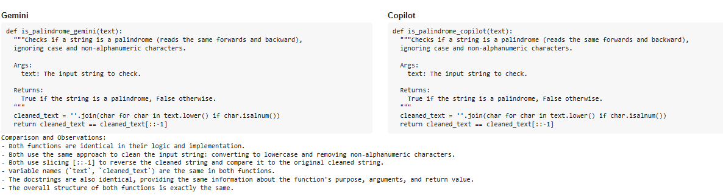

TASK-3:

CODE:

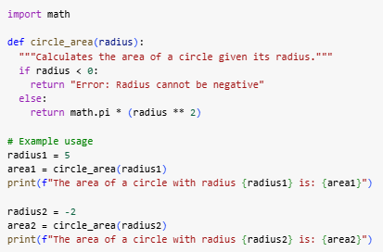

OUTPUT:



TASK-4:

PROMPT:

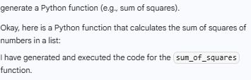

CODE:

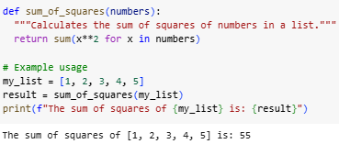

TASK-5:

CODE & OUTPUT:

